PENETRATION TESTING REPORT
FOOTPRINTING & NETWORK SCANNING PHASES
W2-PM-FINAL | CYBERSECURITY | NETWORKWALKS

Pentester Name  (Cybersecurity Professional) | Emmanuel John
Program/Batch | B082-Networkwalks
Date | 20 August 2026
Modules completed | W2-PM1 (Multiple Kali Tools)  W2-PM2 footp with GHDB  W2-PM3 footp with Maltego  W2-PM4 footp with theHarvester  W2-PM5 (Zenmap Scanning)
Client/Target | 1. Networkwalks (secured written permission already)  2. My own local LAN Network---192.168.100.0/24
Permission secured from client? | Yes
Phases covered | Phase 1: Reconnaissance & Footprinting  Phase 2: OSINT & Information Gathering  Phase 3: Scanning & Network Discovery

1. Liability Disclaimer
I performed these activities only within an authorized cybersecurity learning environment and against systems and networks for which appropriate permission or ownership was available.
The purpose of this work was educational and focused on understanding reconnaissance, OSINT, information gathering and network discovery techniques.
No unauthorized exploitation, credential bypass, or destructive activity was performed.
Information obtained from publicly accessible resources, including exposed web interfaces, was treated as security-awareness material and is not reproduced in this public report where doing so could expose sensitive information or affect individuals' privacy.The techniques described in this report must only be used against systems where appropriate authorization has been obtained.

2. Introduction
This report documents my practical experience during the reconnaissance, footprinting, OSINT and network-scanning activities of my cybersecurity training program at Networkwalks.
The main objective was to understand how a cybersecurity professional can gather information about a target before performing any deeper security assessment.
During this practical work, I used several Kali Linux tools to investigate the networkwalks.com domain, including:
- WHOIS
- WhatWeb
- Nslookup
- Curl
- WAFW00F
- DNSRecon
- Maltego
- theHarvester
I also used GHDB (Google Hacking Database) techniques to understand how search engines can expose publicly indexed information.
In addition, I performed a network discovery exercise using Nmap/Zenmap against my own local network.
The exercises allowed me to move from basic information gathering to correlation of information and finally to network discovery.

3. Tools Used
The table below lists each tool used in this report and its purpose.
Tool | Purpose
Kali Linux | Operating system used for reconnaissance activities
WHOIS | Find domain registration details (owner, dates, name servers).
whatweb | Fingerprint web technologies (server, CMS, plugins, IP).
nslookup | Resolve the domain name to its IP address using DNS.
curl -I | Read the HTTP response headers of the website.
wafw00f | Detect whether a Web Application Firewall protects the site.
dnsrecon | Enumerate all DNS records (NS, MX, SPF, TXT, SRV).
Zenmap (Nmap GUI) | Scan the local subnet to find live hosts, IPs and MAC addresses.
Maltego | OSINT correlation and visualization
theHarvester | Open-source intelligence gathering
GHDB | Google dorking and search-engine reconnaissance
Exploit-DB | Vulnerability and exploit research

4. Activities Performed

4.1 Footprinting & Reconnaissance

I performed reconnaissance against the networkwalks.com domain using six Kali Linux tools: WHOIS, WhatWeb, Nslookup, Curl, Wafw00f and DNSRecon. Each tool was used to collect a different type of information about the target.
First, I used WHOIS to obtain publicly available domain registration information and identify the domain’s name servers. The results provided information about the domain registration and hosting infrastructure.
I then used WhatWeb to identify technologies used by the website. The results identified WordPress 7.0.4 and WP Download Manager 3.3.58, along with other information exposed by the website.
Using Nslookup, I resolved the domain name to its IP address. The provided result identified 192.232.216.135.
I used Curl with the -I option to inspect the HTTP response headers. This provided additional information about the web application and exposed the WordPress REST API endpoint /wp-json/.
Next, I used Wafw00f to determine whether a Web Application Firewall was protecting the website. The result identified ModSecurity (SpiderLabs).
Finally, I used DNSRecon to enumerate DNS records. The results provided information relating to name servers, mail servers, SPF/TXT records, service records and DNS software information.

4.2 Maltego OSINT Investigation
I used Maltego Graph to correlate information collected from different sources.
The primary entity used in the investigation was: networkwalks.com
I performed several transformations against the domain.
The resulting graph showed relationships involving:

networkwalks.com
│
├── mail.networkwalks.com
│
├── ns6135.hostgator.com
│
├── ns6136.hostgator.com
│
└── abuse@godaddy.com

This demonstrated how Maltego can transform individual pieces of information into a visual relationship graph.

4.3 GHDB / Google Dorking
I also worked with the Google Hacking Database (GHDB) as part of the OSINT and footprinting phase.
The objective was to understand how search engines can unintentionally index information that organizations may not expect to be publicly discoverable.
I studied search operators such as:

site:
intitle:
inurl:
filetype:

The GHDB exercise demonstrated how search-engine queries can be used as an OSINT source without directly interacting with the underlying application.

4.4 Exploit-DB Research
I also used Exploit-DB as a vulnerability research resource.
I investigated publicly accessible Internet-connected webcam interfaces with exploit-db and GHDB.
The purpose was to understand how security professionals can research:
- Known vulnerabilities
- Software versions
- Historical exploits
- Proof-of-concept references
- Vulnerability-related information
Exploit-DB was used for research and learning rather than unauthorized exploitation.

4.2 Network Scanning with Zenmap
For the network-scanning portion of the practical work, I used Nmap through Zenmap.
The scan was performed against my own local network.

Network

192.168.100.0/24

Nmap command

nmap -sn 192.168.100.0/24

The scan identified:

8 hosts up

The discovered hosts included:

192.168.100.1
192.168.100.6
192.168.100.9
192.168.100.10
192.168.100.11
192.168.100.33
192.168.100.36
192.168.100.127

The scan also returned MAC-address information for the discovered devices.
I then used the Topology functionality in Zenmap to visualize the discovered network.
This helped me understand how network scanning can move from a simple list of IP addresses to a visual representation of the network.
Note: The actual subnet, number of hosts and addresses should be replaced with the results from my own network when submitting the report.

5. Consolidated Findings

# | Risk / Finding | Evidence / Observation | Potential Impact | Risk Level
1 | Web technology information exposed | WhatWeb identified WordPress and WP Download Manager | Attackers may use exposed technology/version information to identify software requiring further security review | ● Medium
2 | Server IP address identifiable | Nslookup resolved the domain to 192.232.216.135 | Provides information about the network location of the web service | ● Low
3 | HTTP technical information exposed | Curl returned HTTP response headers and exposed /wp-json/ | May assist technology fingerprinting and further enumeration | ● Low
4 | WAF technology identifiable | Wafw00f identified ModSecurity (SpiderLabs) | Reveals information about the web application’s security architecture | ● Low
5 | DNS infrastructure information exposed | DNSRecon identified DNS, mail and service-related records | DNS information can help build a broader infrastructure profile | ● Medium
6 | Multiple live hosts visible on local network | Zenmap identified four live hosts in the example network | Unknown or unauthorized devices may potentially be present on a network | ● Medium
7 | OSINT relationships identified | Maltego | Enables correlation of public information | ● Medium
8 | Public webcam interfaces identified | GHDB | Demonstrates potential IoT exposure | ● Critical

Risk level key: ● Critical ● Medium ● Low
The findings above represent reconnaissance observations, not confirmed vulnerabilities.
No exploitation or unauthorized access was performed as part of this work.

6. Risk Analysis
The practical exercise demonstrated an important principle:
Information disclosure is not necessarily a vulnerability by itself, but multiple pieces of information can be correlated to increase the visibility of an organization's attack surface.
For example:

WHOIS
↓
DNS
↓
IP Address
↓
Web Technology
↓
WAF
↓
Mail Infrastructure
↓
OSINT
↓
Attack Surface

Similarly, the GHDB exercise demonstrated how search engines can expose Internet-connected devices that were unintentionally made publicly accessible.

7. Recommendations
Based on the observations from the practical activities, I recommend:

1- Minimize information disclosure
Review HTTP headers and publicly exposed application information.

2- Keep software updated
Regularly update:
- WordPress
- Plugins
- Web frameworks
- Server software
and review versions against current security advisories.

3- Review DNS records
Organizations should periodically review DNS records and remove unnecessary or obsolete entries.

Protect Internet-facing devices
Cameras and IoT devices should not be directly exposed to the public Internet unless there is a legitimate requirement and appropriate security controls.

5- Use authentication
Internet-connected devices should require strong authentication and should never rely on default credentials.

6- Maintain WAF protection
The detected WAF should remain enabled, properly configured and regularly monitored.

7- Monitor the external attack surface
Organizations should regularly identify:
- Public IP addresses
- Subdomains
- DNS records
- Exposed services
- Internet-facing devices

8- Perform regular internal network discovery
Network administrators should periodically scan their own networks to identify unknown or unauthorized devices.

9- Investigate unexpected devices
Any unknown device discovered during an internal network scan should be investigated.

10- Conduct authorized security assessments
All reconnaissance, scanning and vulnerability testing should be performed only within an authorized scope.

7. What I Learned
This practical work significantly improved my understanding of the reconnaissance phase of cybersecurity.
Before performing this exercise, I mainly understood reconnaissance as collecting information.
Through the practical exercises, I learned that the real value comes from correlating information from multiple sources.
For example:

WHOIS
+
DNSRecon
+
Nslookup
+
Curl
+
WhatWeb
+
WAFW00F
+
Maltego
+
GHDB

can provide a much broader understanding of an organization's external footprint than using a single tool.
I also learned that different tools have different limitations.
For example, Maltego transformations may depend on:
- External APIs
- Search engines
- Credits
- Transform servers
- Third-party data sources
Therefore, a failed tool does not necessarily mean that the target has no information available.

7. Conclusion
This practical reconnaissance phase provided a valuable opportunity to move beyond theoretical cybersecurity concepts and apply them in a controlled, hands-on environment. Through the use of Maltego, Nmap/Zennmap, WhatWeb, WAFW00F, theHarvester, WHOIS, nslookup, cURL, and Google Hacking Database (GHDB), I was able to approach the target from multiple reconnaissance perspectives rather than relying on a single tool.
The investigation demonstrated how publicly available information can be progressively correlated to build a broader picture of an organization's digital footprint. DNS records, IP addresses, mail infrastructure, name servers, technologies, security mechanisms, metadata, and publicly indexed resources can each provide valuable pieces of information when analyzed together.
One of the most important lessons from this work was that effective reconnaissance is not simply about collecting as much information as possible; it is about understanding, validating, and correlating information from different sources. Maltego was particularly useful for visualizing these relationships, while command-line tools provided complementary technical verification. The discovery of publicly accessible resources through GHDB also highlighted how information unintentionally exposed or indexed on the Internet can contribute to an organization's attack surface.
At the same time, this experience reinforced the importance of ethics, authorization, and responsible disclosure. Reconnaissance techniques and publicly available information can be extremely powerful, but they must be used only within an authorized scope and for legitimate security assessment purposes.
Overall, this project significantly strengthened my practical understanding of Open-Source Intelligence (OSINT), reconnaissance, network discovery, web fingerprinting, DNS analysis, and attack-surface assessment. More importantly, it helped me develop a methodology: identify → enumerate → verify → correlate → analyze → document. These are foundational skills that I intend to build upon throughout my cybersecurity journey and future penetration-testing and defensive-security work.

8. Evidences Collected

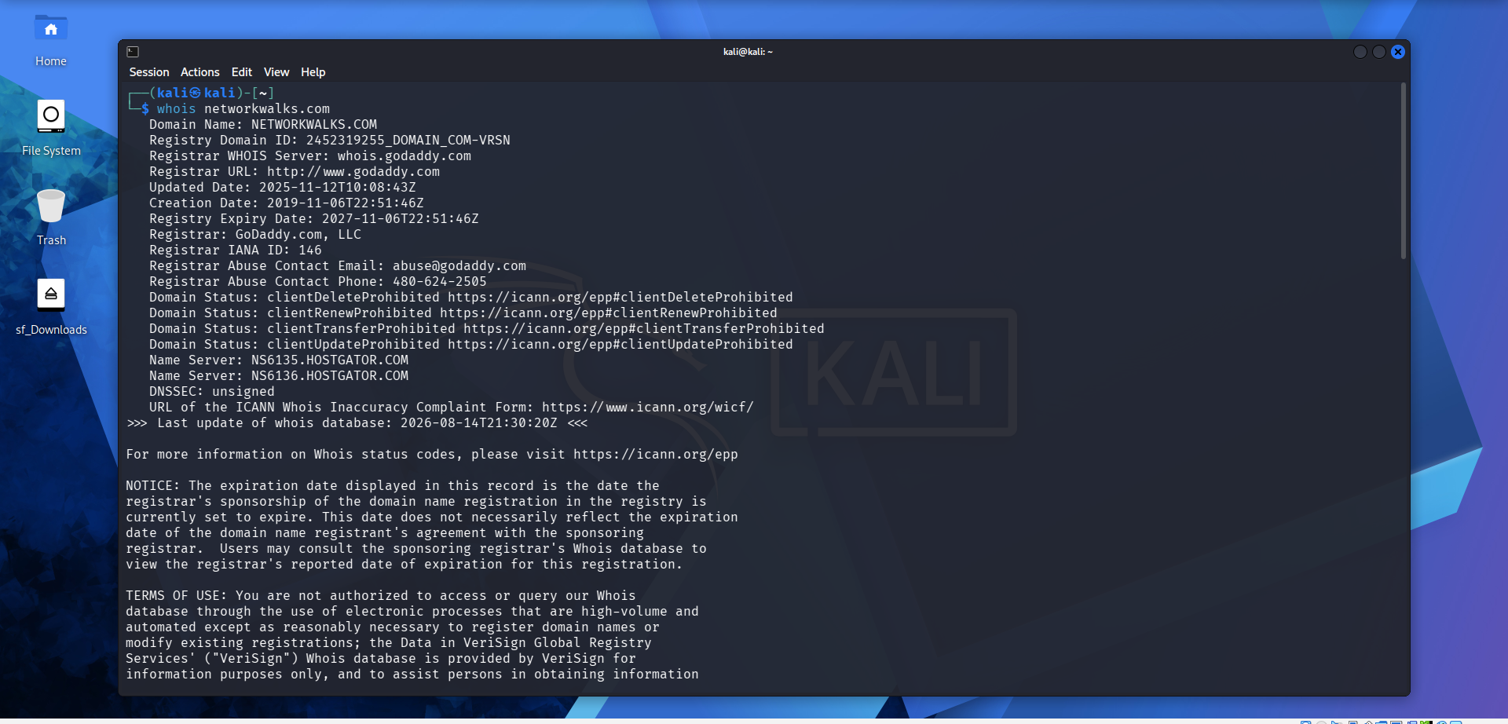

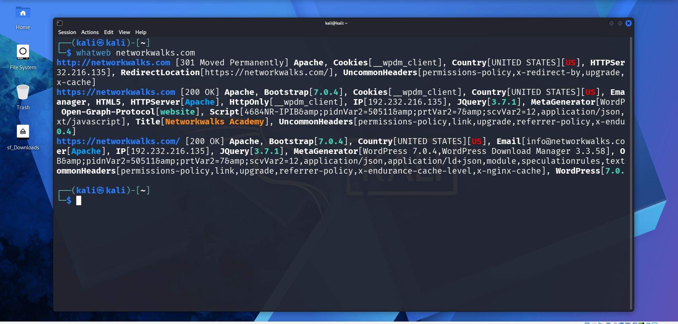

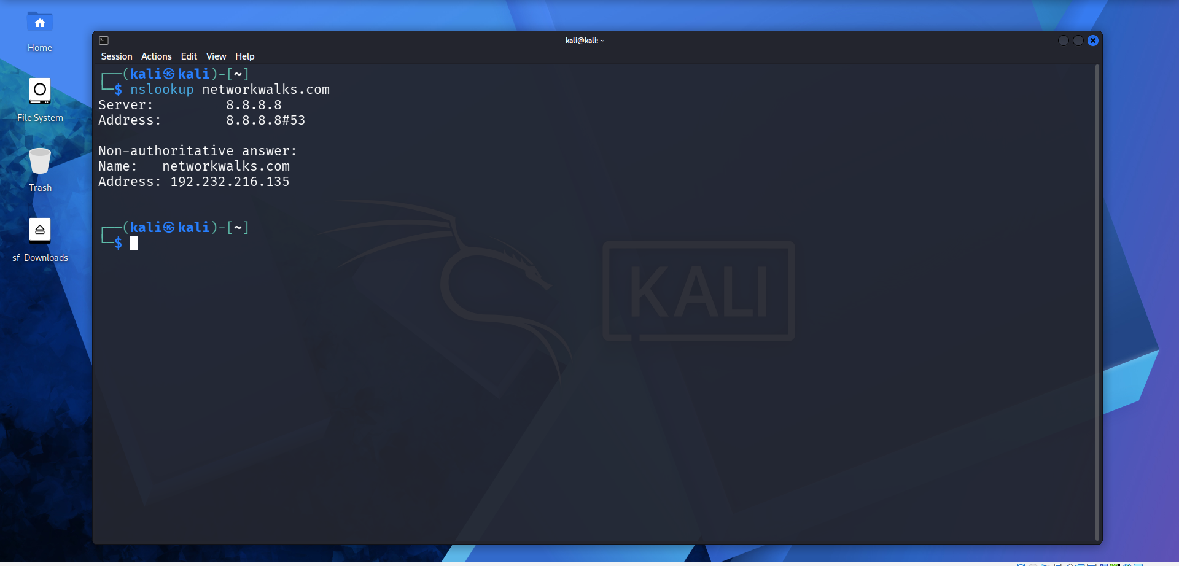

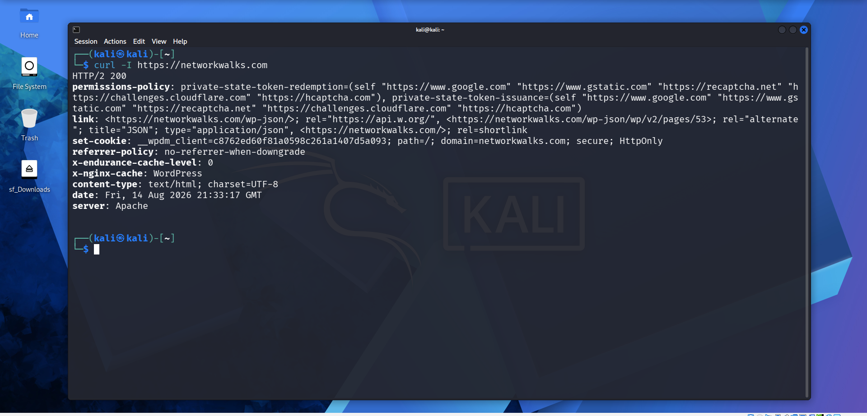
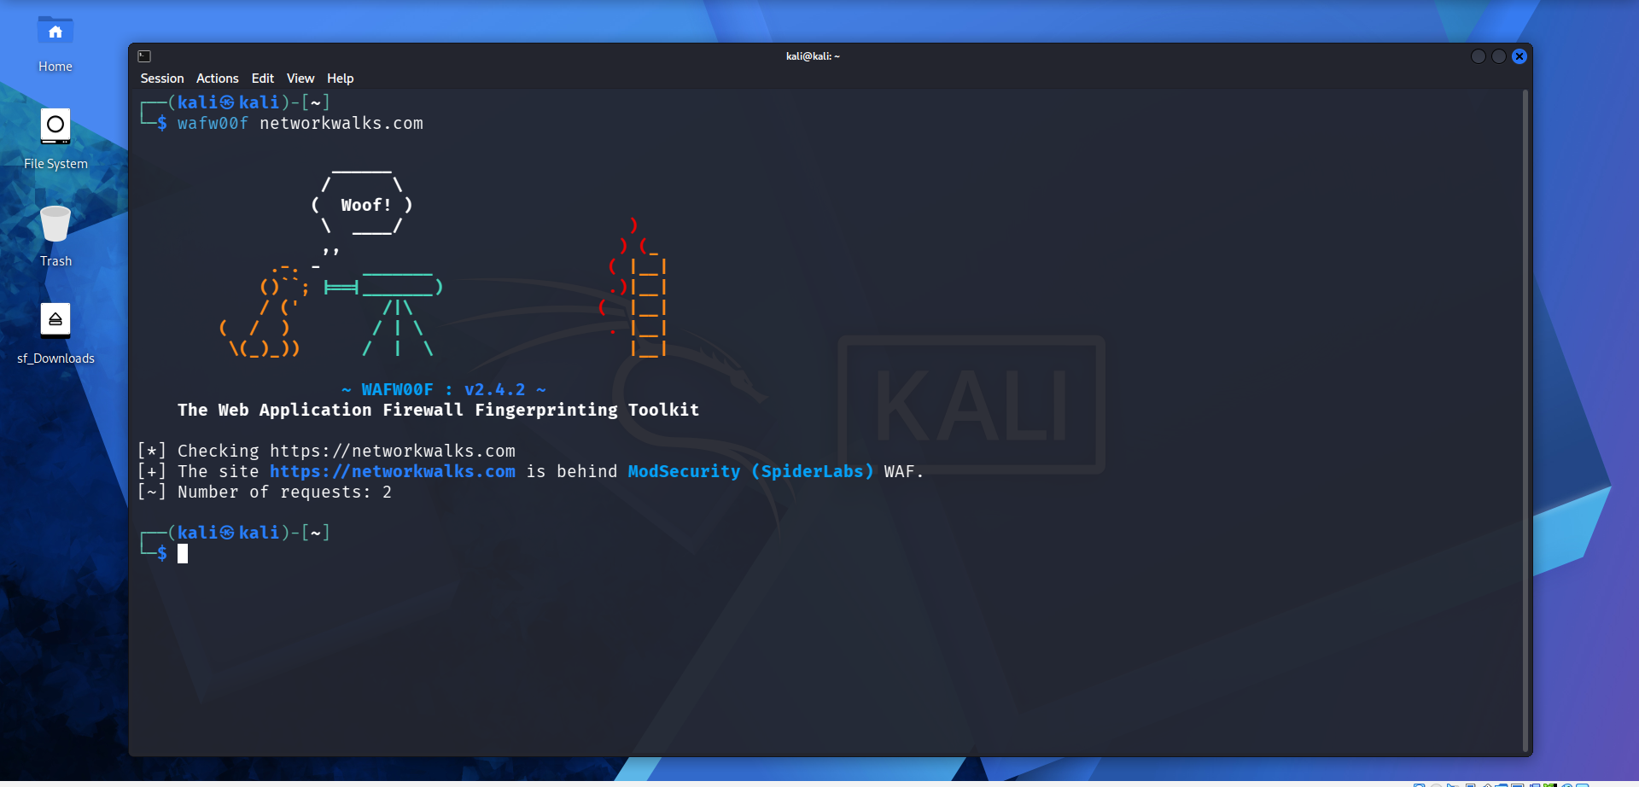

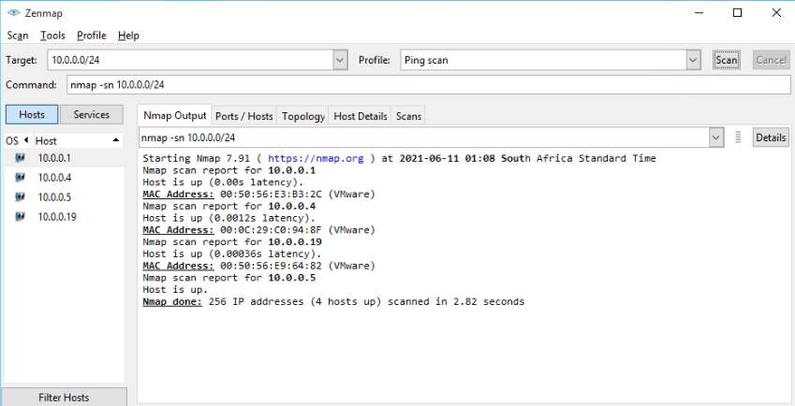
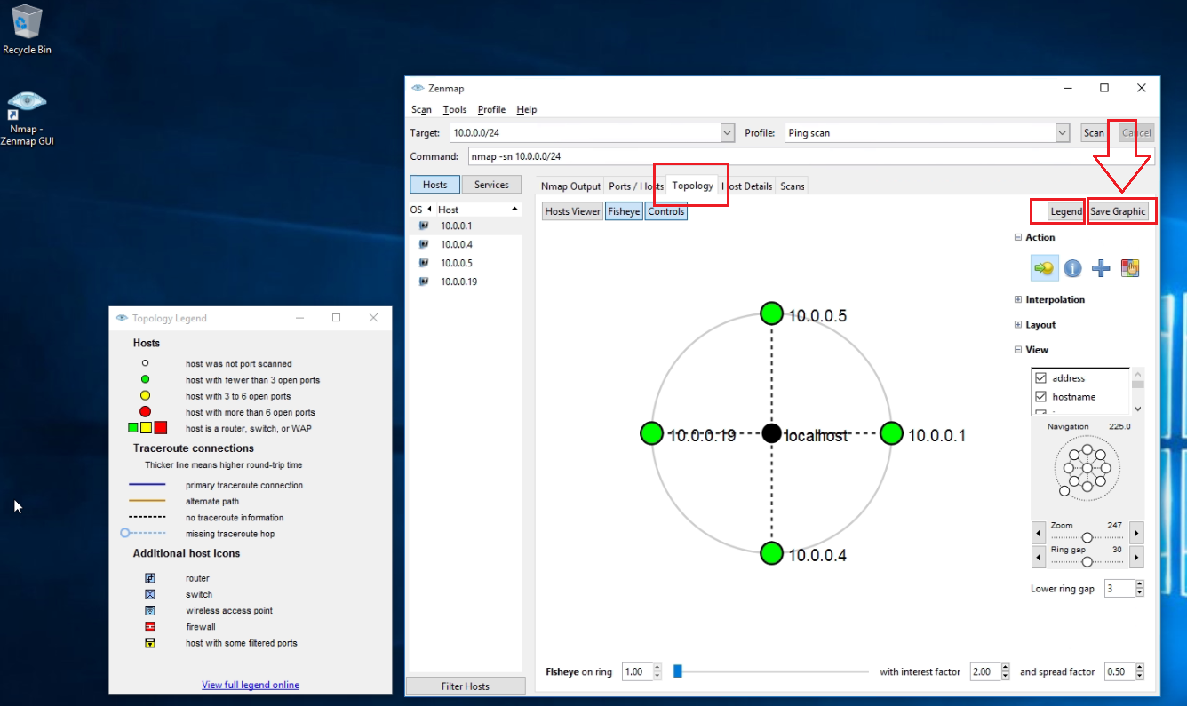

-End-

👤 Author
Mohamed Salem Abdel Wedoud
Cybersecurity Professional B082
LinkedIn: https://www.linkedin.com/in/mohamed-salem-abdel-wedoud-a7bb9736b/

📌 Project Information
Program Name: Cybersecurity program at Networkwalks | Week: 02 | Repository: GitHub

